**Homework #5 - Pandas and Data Visualization**

* Due Nov 14, 2019 by 4pm
* Points 10
* Submitting a file upload

Complete these exercises and submit a single Jupyter Notebook file (in .html format, not .ipynb) that contains your responses by **4PM on Thursday 11/14**. Late assignments will be penalized up to 2 points per day (20%), unless prior arrangements have been made to submit the assignment after the deadline.

The notebook should be well organized. Each section should be **clearly labeled with the exercise (and part) that it addresses** (e.g., Exercise #1a, #1b, #2) in a Markdown cell block. Use (clear and concise) comments as needed to help describe each step of your process. All notebook cells that contain essential steps should be executed and the output should be visible, so as to demonstrate your successful completion of the exercise. If you cannot complete an exercise in its entirety, you should make an effort to demonstrate your intermediate progress in order to maximize partial credit, and move forward as best as possible. You may submit any written answers to the exercises in the notebook as text cells.

**Academic Integrity:** Each student is expected to submit his or her own original work. You may collaborate with your classmates on the concepts of the homework assignment, but you should not submit the same documentation for any part of the assignment. Submissions that contain significant similarities will be reported directly to the Office of Student Conduct.

**Background**

We will be examining data from health inspections for restaurants, nursing homes, and schools in Prince George's County.  Download the data [herePreview the document](https://umd.instructure.com/courses/1266059/files/54473371/download?wrap=1).

[Source: https://data.princegeorgescountymd.gov/Health/Food-Inspection/umjn-t2iz (Links to an external site.)](https://data.princegeorgescountymd.gov/Health/Food-Inspection/umjn-t2iz)

**Exercise #1 - Data Cleaning**

Step 1.1 - Read in the data. Create a table of the unique values of Category. Which values do you believe represent a restaurant? Explain which categories you chose in a markdown cell. Create a single dummy variable for restaurant that combines multiple values from Category.

Step 1.2 - Convert the Inspection_date column into a datetime column. Create a new column for the year of the inspection. Create a new column for the month of the inspection. Create a column for the year and month.

Step 1.3 - For each column with the type of compliance, e.g. "Rodent and Insects," create a dummy variable that is 1 if the establishment is out of compliance and 0 otherwise. Use np.nan for not applicable. Drop the string columns (retain only the dummy variables).

Step 1.4 - Create a new column that contains the number of violations for that inspection (the number of categories where the establishment was not in compliance). Create a dummy variable that is 1 if the establishment is out of compliance in any category.

Step 1.5 - For establishments with multiple inspections, create a new DataFrame in wide format. Keep only the establishment ID, Category, Inspection_date, and number of violations. Make sure category is consistent within ID and resolve any discrepancies if necessary (i.e. each establishment has only one category). Reshape from long to wide (pivot) such that each establishment is a row and you have a column for the date and number of violations for inspection 1, inspection 2, inspection 3, etc.

**Exercise #2 - Summary Statistics/Grouped Data**

Step 2.1 - What is the most common type of violation? The compliance categories are not mutually exclusive because one restaurant can have multiple violations. Create a table with the number of violations by violation type. Sort the table from the most common to least common violations.

Step 2.2 - For establishments with multiple inspections, how many reinspections does it take for an establishment to become compliant? Create a table where each row is the number of inspections a restaurant has had and the columns are the number of reinspections until the establishment becomes compliant. Write 2-4 sentences with your observations. A mock up of this table is below (you will have more rows).

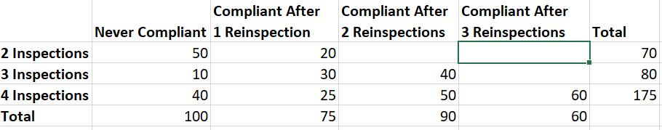

**Exercise #3 - Data Visualization**

For the data visualization tasks below, you may choose to use any Python visualization package you wish. Make sure all graphs are labeled appropriately. Limit your analysis to restaurants using the dummy variable indicator you created in 1.1.

Step 3.1 - Create a bar graph showing the results of 2.1.

Step 3.2 - Create a line graph that shows the percent of restaurant inspections that have at least one violation by month and year. Are inspections getting harder or easier over time? Is there a particular month where more restaurants pass? Write 2-4 sentences with your observations.

Step 3.3 - Create a map that shows all of the restaurants. Color the restaurants with at least one violation in red. Are there particular areas with more violations? If there are clusters of violations, either through interactive visualization or by manually inspecting the data, look at the types of violations where there are clusters. Are there any trends? Write 2-4 sentences with your observations. If you did not use interactive visualization, explain how you explored trends in violation type by area. You may also create a second map showing violation types.

**Please check your .html file for the map. If your map is not rendering in the html version of your Jupyter notebook, please submit screenshots or image files of your map(s) inside a document or PDF in addition to your html file.**